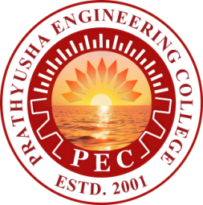
PRATHYUSHA ENGINEERING COLLEGE
(An Autonomous Institution)
DEPARTMENT OF TRAINING, PLACEMENT AND STUDENT AFFAIRS
NAME | DEPARTMENT | DESIGNATION
Ms. ANITHA R | AI & DS | Assistant Professor
Ms. SUREKHA R | BIO TECH | Assistant Professor
Ms. LAVANYA M | CSE | Assistant Professor
Mr. RAJESH J | EEE | Assistant Professor
Ms. PRIYADHARSHINI A | ECE | Assistant Professor
Ms. S PRADEEPA | IT | Assistant Professor
Mr. MEGANATHAN D | MECH | Assistant Professor
Ms. JACULINE L | PLACEMENT | Placement Coordinator

