|  |  |  |  |  |
| --- | --- | --- | --- | --- |
| **S.No** | **Name of the student** | **Date** | **Host name** | **Achieved** |
| 1 | Myleshwaran | 29/09/2024 | Thiruvallur | Gold Medal |
| 2 | Myleshwaran | 23/12/2024 | Anna university | Gold Medal |
| 3 | Myleshwaran | 22/02/2025 | VIT, Vellore | Gold Medal |

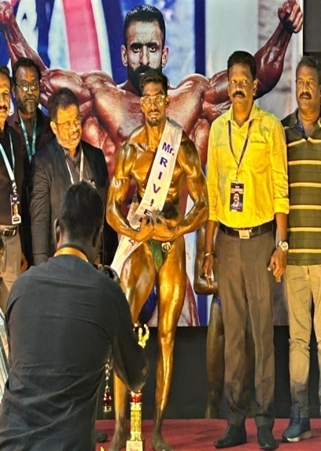 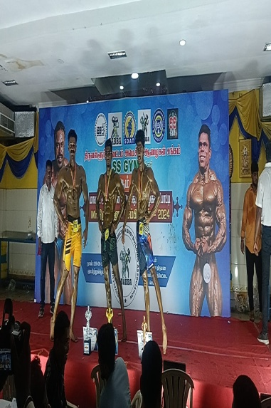 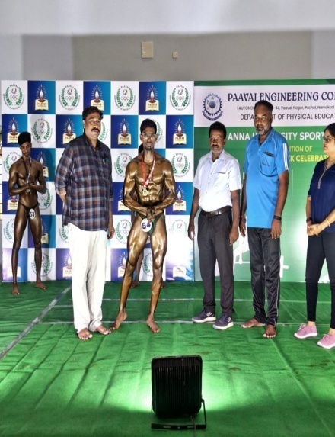

|  |  |  |  |  |
| --- | --- | --- | --- | --- |
| **S.No** | **Name of the student** | **Date** | **Host name** | **Achieved** |
| 4 | Umashankar | 29/09/2024 | New Prince Shri Bhavani College Of Engineering & Technology | 3rd Prize |

