|  |  |  |  |  |
| --- | --- | --- | --- | --- |
| S.No | Name of the guest lecture/ Workshop/Seminars/Conference | Date | Resource person | Company name |
| 1. | Opportunity in industry for mechanical engineering | 21-09-24 | S.Sendooran | Babcock power APAC pvt ltd |

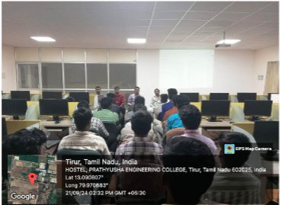

|  |  |  |  |  |
| --- | --- | --- | --- | --- |
| S.No | Name of the guest lecture/ Workshop/Seminars/Conference | Date | Resource person | Company name |
| 2. | Advanced Acoustic Technologies in Automobiles | 19-02-25 | Mr. Anilbabu S | KFB India |

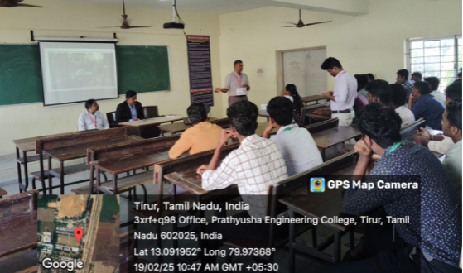

|  |  |  |  |  |
| --- | --- | --- | --- | --- |
| S.No | Name of the guest lecture/ Workshop/Seminars/Conference | Date | Resource person | Company name |
| 3. | Advancements in Automobile safery | 27.02.2025 | Mr. B.Koovarasan | TRIONE CADD |

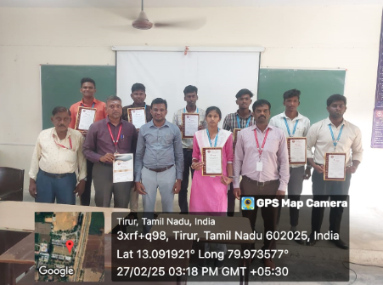

|  |  |  |  |  |
| --- | --- | --- | --- | --- |
| S.No | Name of the guest lecture/ Workshop/Seminars/Conference | Date | Resource person | Company name |
| 4. | CAD Fundamentals using Autodesk Fusion 360 | 11..03.2025 &12.3.2025 | Mr. YasarArafath | USAM Technology Solutions |

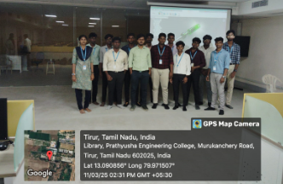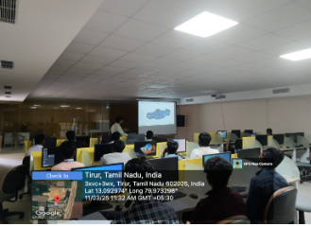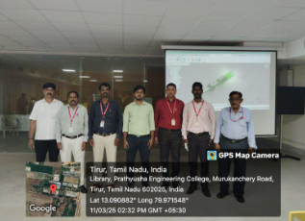

|  |  |  |  |  |
| --- | --- | --- | --- | --- |
| S.No | Name of the guest lecture/ Workshop/Seminars/Conference | Date | Resource person | Company name |
| 5. | Industrial Visit | 24-08-2024 | NA | DEO VERSE VR DEVELOPERS |

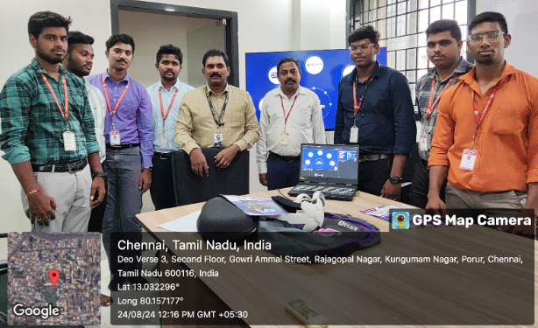

|  |  |  |  |  |
| --- | --- | --- | --- | --- |
| S.No | Name of the guest lecture/ Workshop/Seminars/Conference | Date | Resource person | Company name |
| 6. | Industrial Visit | 8-10-2024 | NA | SRI KVS INDUSTRIES |

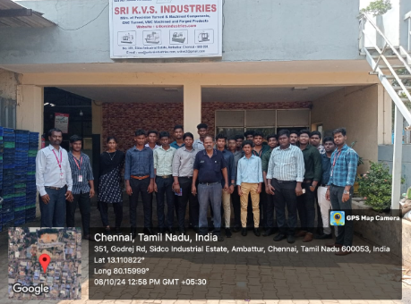

|  |  |  |  |  |
| --- | --- | --- | --- | --- |
| S.No | Name of the guest lecture/ Workshop/Seminars/Conference | Date | Resource person | Company name |
| 7. | Industrial Visit | 25.02.2025 | NA | RETECH |

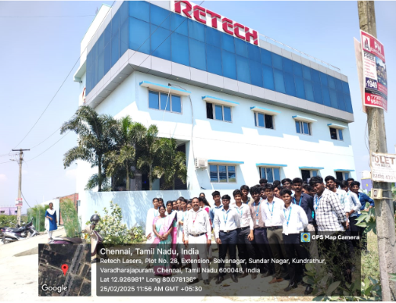

|  |  |  |  |  |
| --- | --- | --- | --- | --- |
| S.No | Name of the guest lecture/ Workshop/Seminars/Conference | Date | Resource person | Company name |
| 8. | Industrial Visit | 21.02.2025 | NA | CIPET |

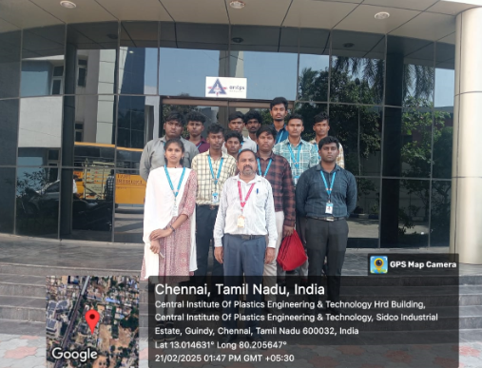

|  |  |  |  |  |
| --- | --- | --- | --- | --- |
| S.No | Name of the guest lecture/ Workshop/Seminars/Conference | Date | Resource person | Current Designation |
| 9. | Alumni interaction with 1st year Mechanical | 22.01.2025 | Md. Abbas | MS in Germany |

**“Exploring Global Opportunities: My Journey from Mechanical Engineering to Pursuing an MS in Germany”**

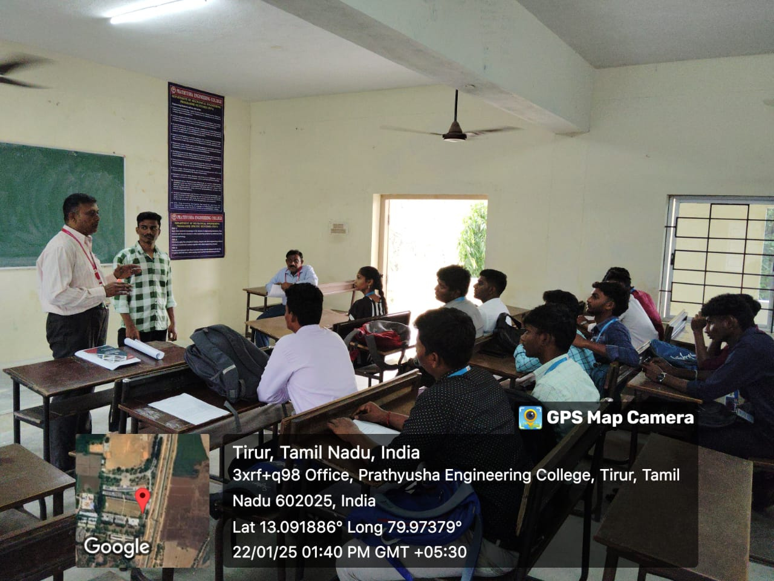

|  |  |  |  |  |
| --- | --- | --- | --- | --- |
| S.No | Name of the guest lecture/ Workshop/Seminars/Conference | Date | Resource person | Current Designation |
| 10. | Alumni interaction with 1st year Mechanical students | 20.03.2025 | Naveen | Software engineer at Wipro |

**“Bridging the Gap: From Mechanical Engineering to a Career in IT – A Journey into Software Engineering”**

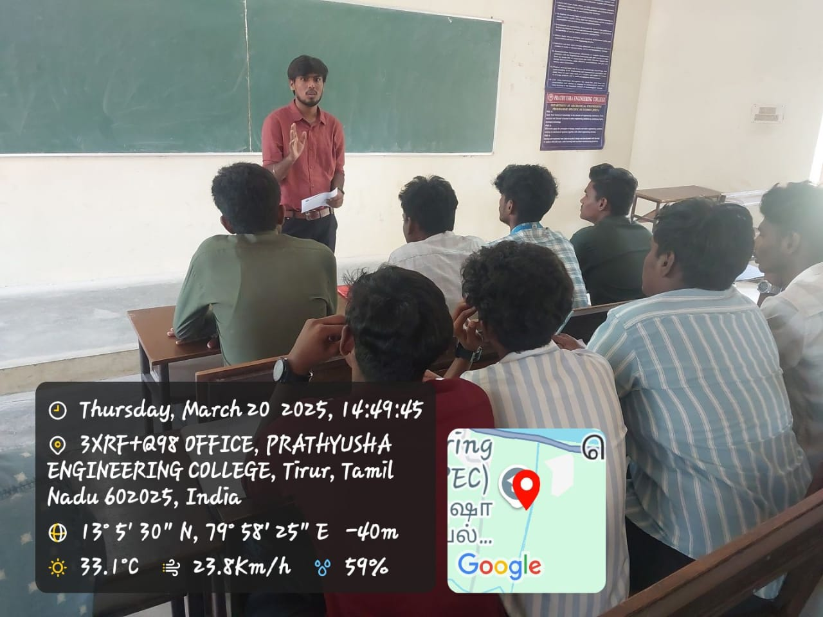

|  |  |  |  |  |
| --- | --- | --- | --- | --- |
| S.No | Name of the guest lecture/ Workshop/Seminars/Conference | Date | Resource person | Current Designation |
| 11. | Alumni interaction with 1st year Mechanical students | 10.04.2025 | Srikanth | Graduate engineer trainee at Moglix |

**“From Campus to Corporate: My Experience as a Graduate Engineer Trainee in the Supply Chain Industry"**

