CAD/CAM LABORATORY
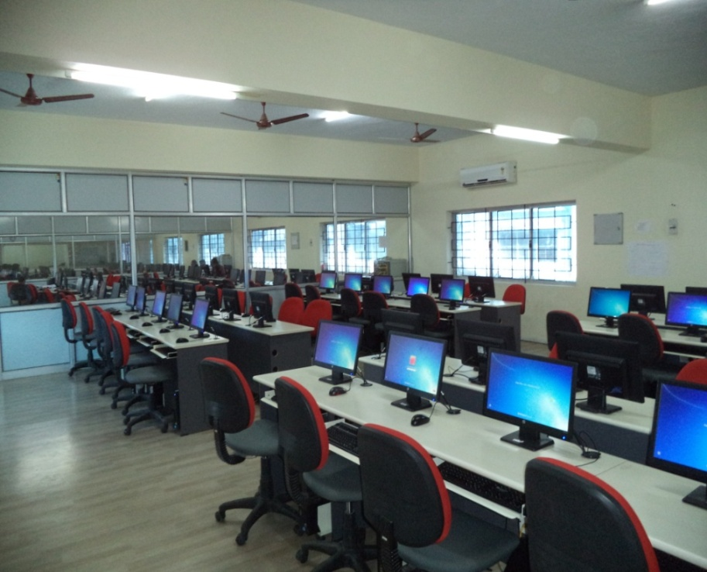
MANUFACTURING TECHNOLOGY LABORATORY - I
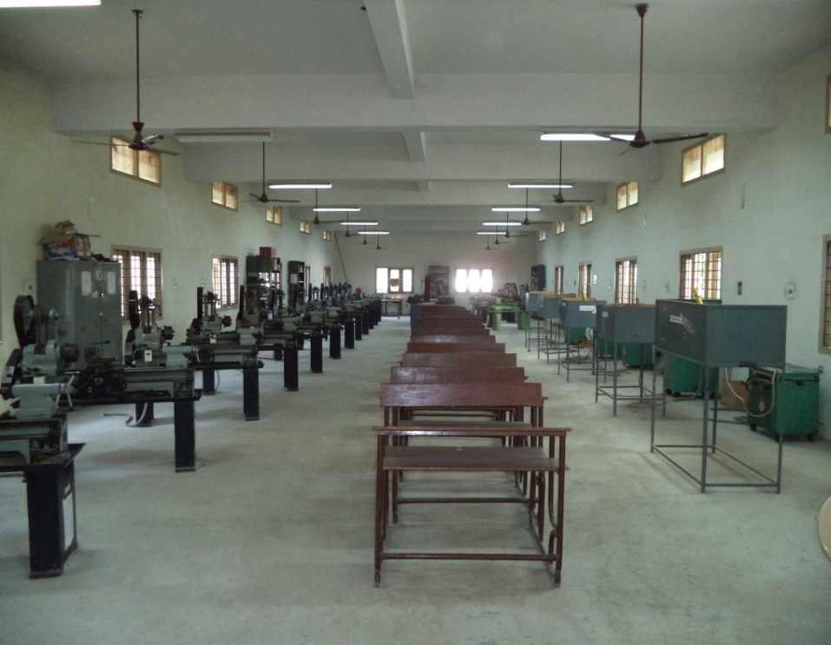

MANUFACTURING TECHNOLOGY LABORATORY
- II
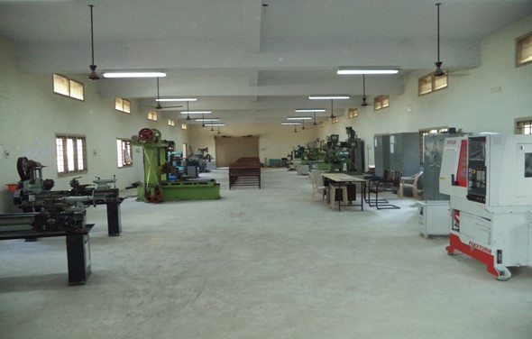
DYNAMICS LABORATORY
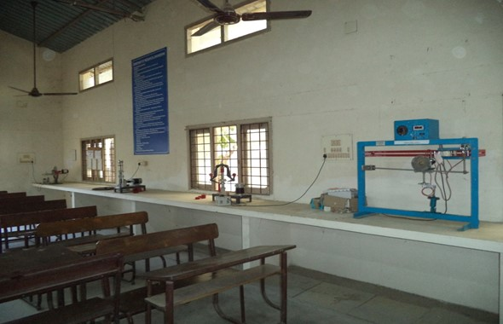

MECHATRONICSLABORATORY
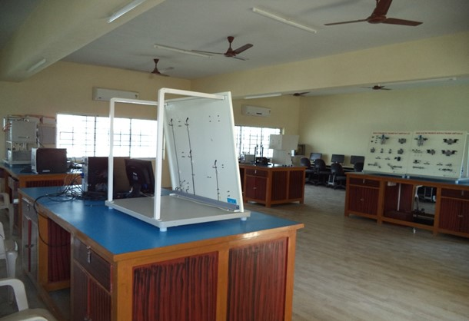
THERMAL ENGINEERING LABORATORY - I
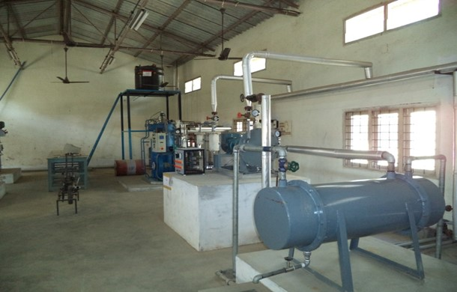

THERMAL ENGINEERING LABORATORY - II
